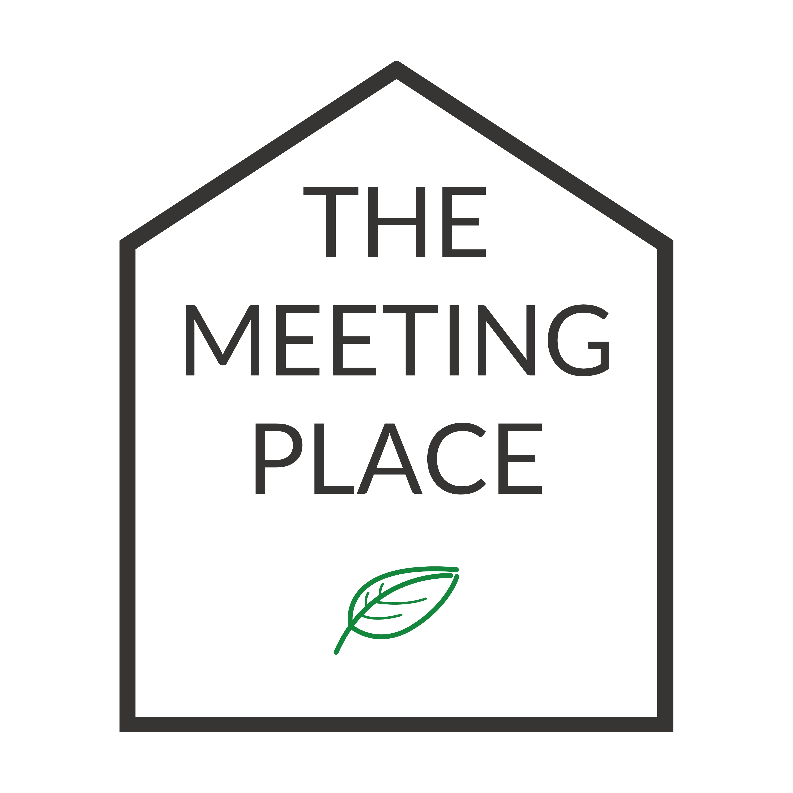 | The Meeting Place, Trafford Ecology Park, Lake Road, Manchester, M17 1TU  Tel: 0161 220 1000  Email: greatermanchester@groundwork.org.uk
YOUR DETAILS

Company
Contact Name
Address

PAYMENT DETAILS
Payment method: | Card payment | Invoice | BACS
Purchase Order No.
Accounts contact, if different from above:
Name:
Email
Phone
Address:

ROOM BOOKING
Date:
Full day Half day

Time in: |  |  | Time out:
Number of people attending:
Please detail any access requirements of attendees that we should be aware of:
Equipment required:
Flip chart |  | TV Screen |  | Conference phone
Room layout :
U-Shape (Max: 14 with 4 spaces restricted legroom)
Polo (Max: 14 with 4 spaces restricted legroom)
Classroom (Max: 10)
Workshop (Max: 20 with 2 spaces restricted legroom)

CORPORATE VOLUNTEERING
Morning Afternoon

Number of people attending at £45 donation per head:

REFRESHMENTS
Tea, coffee and milk are provided in the room for you to use (note: if you require non-dairy milk please bring your own).
Lunch can be provided at an additional charge, please confirm which options you require and at what time you would like these.
Typically, we only attend the room at lunch time or when requested.
NOTE: Cold water can be found in the fridge.

 |  | Number & Caterer name required | Time you would like lunch
Menu A | £7.10 (South Catering) or £10 (Open Kitchen)
Menu B | £10.95 (South Catering) or £17 (Open Kitchen)
Menu C | £13.95 (South Catering) or £19 (Open Kitchen_

Dietary needs:

Please ensure you have read the full terms & conditions of booking (attached) and have completed the above in full. Please note, your booking is not confirmed until we have receive this completed booking form.

I confirm I have read and agree to the terms of booking:

Signed:

Name:

Date:

